**BIKE RENTAL PREDICTION**

**OUTPUT**

**Missing Value Analysis**

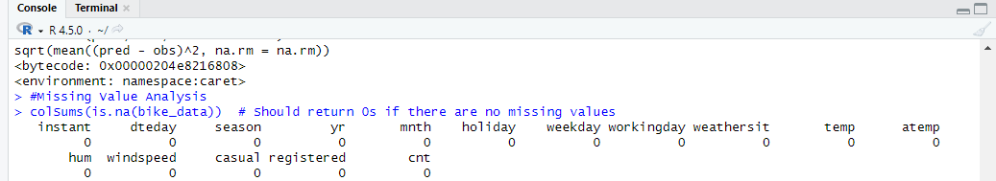

**#Monthly distribution of total rentals**

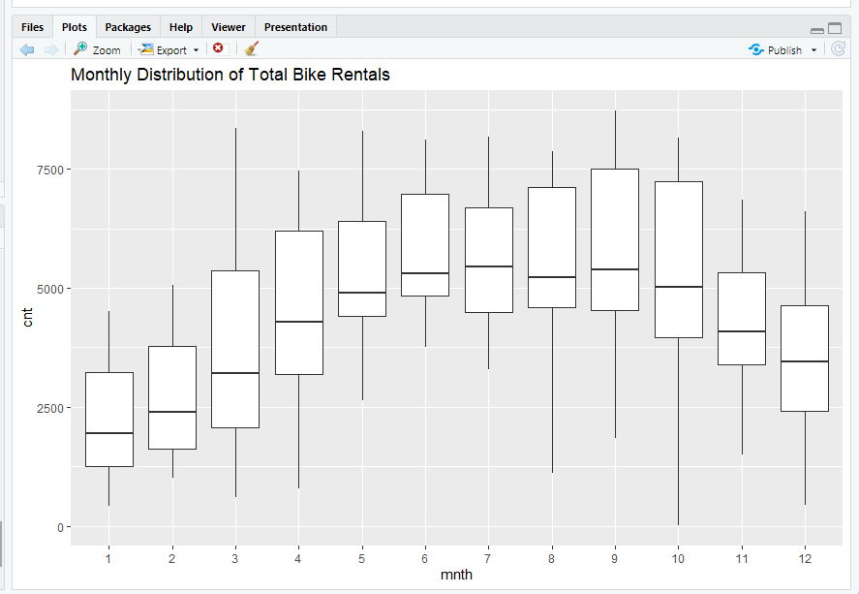

**# Yearly distribution of total rentals**

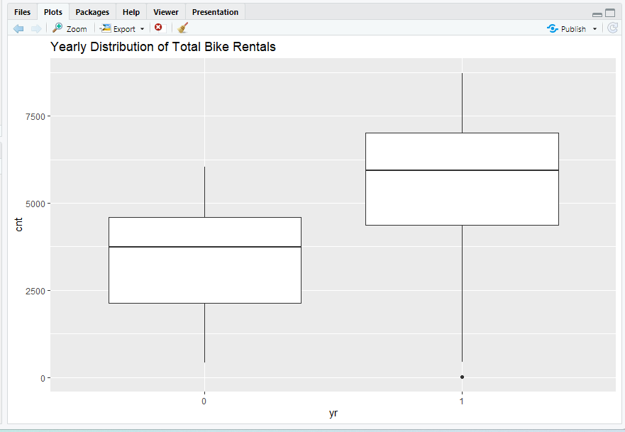

**Train Model & Evaluate Performance**

